**Sales**

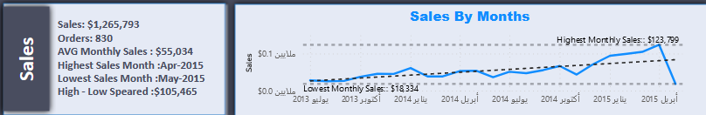-Sales

Select CAST(Sum(sales) As decimal(13)) AS Sales

From SQLToturial.dbo.order_detailsN



-Orders

Select Count (Distinct orderId) As orders

from SQLToturial.dbo.order_detailsN

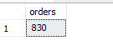

-AVG Monthly Sales

With ss as(

Select DATEPART(year,b.orderDate) as _year,DATEPART(month,b.orderDate) as _Month,Sum(a.sales)as _Sum

From SQLToturial.dbo.order_detailsN a

join SQLToturial.dbo.ordersN b

On a.orderID =b.orderID

Group by DATEPART(year,b.orderDate) ,DATEPART(month,b.orderDate)

)

select Round(AVG(_sum),0) AS AVG_Monthly_Sales

From ss;

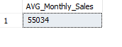

-Highest Sales Month

Select FORMAT(b.orderDate,'MMM-yyyy') As Dates,Round(Sum(a.sales),0) AS _Sum_Sales

From SQLToturial.dbo.order_detailsN A

Join SQLToturial.dbo.ordersN B

On A.orderID=B.orderID

Group by FORMAT(b.orderDate,'MMM-yyyy')

Order by _Sum_Sales DESC

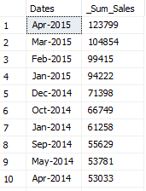

-Lowest Sales Month

Select FORMAT(orderDate,'MMM-yyyy') AS Dates,Round(Sum(B.sales),0) AS_Sum_Sales

From SQLToturial.dbo.ordersN A

join SQLToturial.dbo.order_detailsN B

ON A.orderID=B.orderID

Group By FORMAT(orderDate,'MMM-yyyy')

Order By Sum(B.sales) ASC

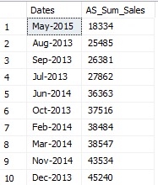

-High-Low Speared

With SS AS(

Select FORMAT(orderDate,'MMM-yyyy') As Dates,Sum(Sales) as _Sum_Sales

From SQLToturial.dbo.order_detailsN A

Join SQLToturial.dbo.ordersN B

On A.orderID=B.orderID

Group By FORMAT(orderDate,'MMM-yyyy')

)

Select

MAX(_Sum_Sales)-Min(_Sum_Sales)

From SS

-Sales By Month

Select { FN MONTHNAME(orderDate)} AS 'Month',YEAR(orderDate) AS 'Year',Sum(Sales) AS Sales_monthly,Count(Distinct A.orderID) AS Orders

From SQLToturial.dbo.order_detailsN A

Join SQLToturial.dbo.ordersN B

On A.orderID=B.orderID

Group By { FN MONTHNAME(orderDate)},MONTH(orderDate),YEAR(orderDate)

Order By YEAR(orderDate),Month(orderDate)

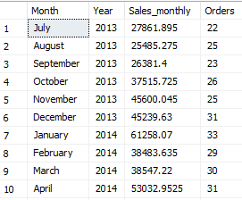

**Shipping**

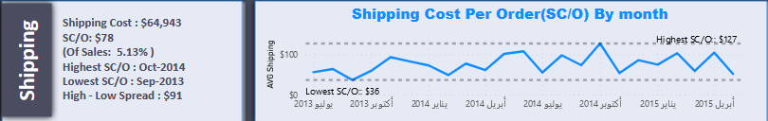

-Shipping Cost

Select CAST(Sum(Freight)AS money) AS _Freight

From SQLToturial.dbo.ordersN



-AVG Shipping Cost(SC/O)

Select CAST(AVG(Freight)AS decimal(2)) As Avr_Fright

From SQLToturial.dbo.ordersN



-Highest(SC/O)

Select FORMAT(shippedDate,'MMM-yyyy') AS DATES,Round(AVG(Freight),0) AS FR

From SQLToturial.dbo.ordersN

Group by FORMAT(shippedDate,'MMM-yyyy')

Order By FR DESC

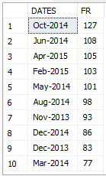

-Lowest(SC/O)

Select FORMAT(ShippedDate,'MMM-yyyy') As Dates,Round(AVG(Freight),0) AS FR

From SQLToturial.dbo.ordersN

Group By Format(ShippedDate,'MMM-yyyy')

Order by FR ASC

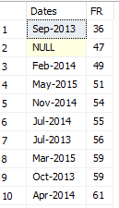

-High Low Spread

With SP AS(

Select FORMAT(shippedDate,'MMM-yyyy') AS Dates,Avg(freight) AS FR

From SQLToturial.dbo.ordersN

Group By FORMAT(shippedDate,'MMM-yyyy')

)

Select CAST(Max(FR)-MIN(FR) AS Decimal(4,2)) AS Speard

From SP



-Shipping Cost Per Order By Month

Select {FN MONTHNAME(ShippedDate)} AS 'Month',Year(ShippedDate) AS 'Year',Round(AVG(Freight),0) AS 'FR'

From SQLToturial.dbo.ordersN

Group by {FN MONTHNAME(ShippedDate)},MONTH(shippedDate),YEAR(shippedDate)

Order By YEAR(shippedDate),MONTH(shippedDate)

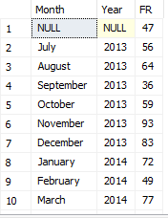

**Customer**

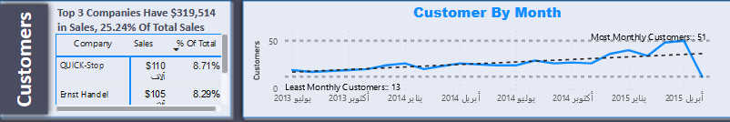

-Top 3 Company Sales

--Add New Colmun

Alter Table OrdersN Add CompanyName Nvarchar(255);

--Update Column From Table CustomerId

Update SQLToturial.dbo.ordersN

Set CompanyName=B.companyName

From SQLToturial.dbo.ordersN A

Join SQLToturial.dbo.customersN B

On A.customerID=B.customerID

Where A.customerID=B.customerID

Select Top(3) A.CompanyName,CAST(Sum(Sales)AS money) AS Total,ROUND(sum(sales) / Sum(Sum(Sales)) over(),4)*100 As Total_of_Percentage

From SQLToturial.dbo.ordersN A

Join SQLToturial.dbo.order_detailsN B

on A.orderID=B.orderID

Group by A.CompanyName

order By Total_of_Percentage DESC

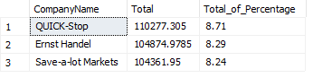

-Total Of 3 Company Sales And Percentage

With Top3 AS(

Select Top(3) A.CompanyName,CAST(Sum(Sales)AS money) AS Total,ROUND(sum(sales) / Sum(Sum(Sales)) over(),4)*100 As Total_of_Percentage

From SQLToturial.dbo.ordersN A

Join SQLToturial.dbo.order_detailsN B

on A.orderID=B.orderID

Group by A.CompanyName

order By Total_of_Percentage DESC

)

Select Cast(Sum(Total)AS decimal(8,2) ) AS Sales ,Round(Sum(Total_of_Percentage),4) As '%Of_Total'

From Top3

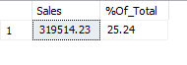

-Customer By Month

Select {FN MONTHNAME(orderDate)} AS Month,Year(orderDate) AS Year,COUNT(CustomerId)As Orders

From SQLToturial.dbo.ordersN

Group By {FN MONTHNAME(orderDate)},Month(orderDate),YEAR(OrderDate)

order By Year(OrderDate),MONTH(OrderDate)

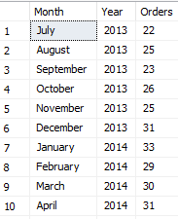

**Product**

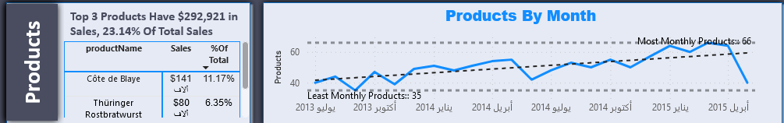

-Top 3 Product Sales

Select TOP(3) productName,Sum(Sales) AS Sal,Round(SUM(sales) / Sum(Sum(Sales))Over(),4)*100 AS '%OF_Total_Sales'

From SQLToturial.Dbo.productsN A

Join SQLToturial.Dbo.order_detailsN B

On A.productID=B.productID

Group By productName

Order By Sal DESC

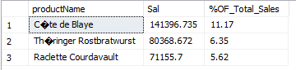

-Total 3 Product Sales And Percentage

With TopProduct AS(

Select Top(3) productName,Sum(Sales)AS Sal,Round(Sum(Sales) / Sum(Sum(Sales)) over(),4)*100 As '%Of_Total_Sales'

From SQLToturial.dbo.productsN A

Join SQLToturial.Dbo.order_detailsN B

on A.productID=B.productID

Group by productName

Order By Sal DESC

)

Select Sum(Sal) AS Top_3_Product_Sales,Sum([%Of_Total_Sales]) AS '%OF Total Percentage'

From TopProduct



-Product By Month

Select {FN MONTHNAME(OrderDate)} AS MONTH ,YEAR(orderDate)AS Year,Count(DISTINCT productID)As Product

from SQLToturial.dbo.order_detailsN A

Join SQLToturial.Dbo.ordersN b

On A.orderID=B.orderID

Group by {FN MONTHNAME(OrderDate)},MONTH(OrderDate),Year(OrderDate)

Order by YEAR(orderDate),Month(OrderDate)

